  - Chris Lynch

TagForge Design
Industrial Automation Tag Database
SDEV-435 Applied Software Practice September 14, 2026

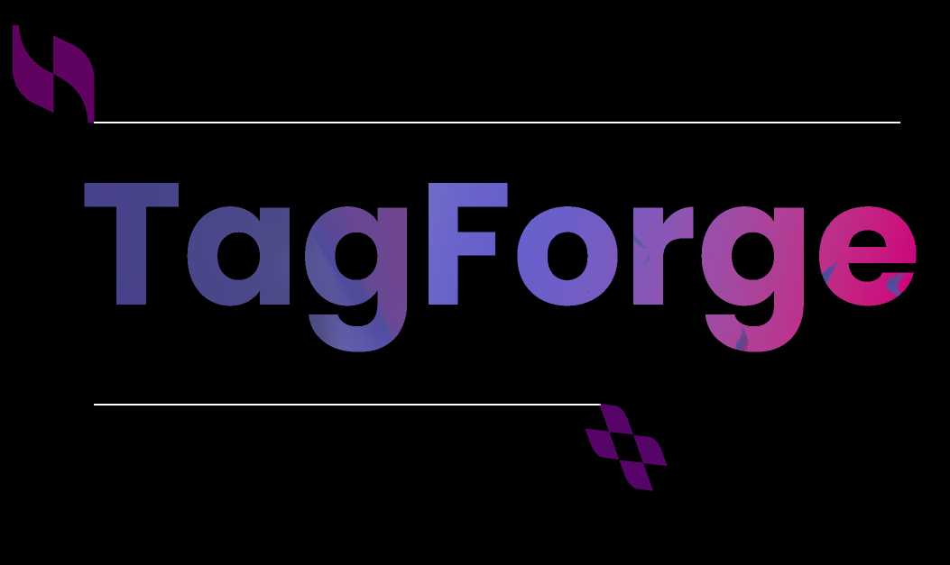

Background
TagForge is a local-first database utility for creating, validating, organizing, and retrieving industrial automation tag information. On a typical controls project the tag list is spread across the PLC program, the HMI or SCADA application, a commissioning spreadsheet, and a set of field notes. Each copy is edited by a different person at a different time, and none of them is authoritative. The cost of that shows up late: a scaling value that disagrees with the transmitter range, an alarm limit that was never updated after a process change, or a tag that exists in the HMI and nowhere else.
The intended users are controls engineers, system integrators, maintenance and commissioning technicians, and small manufacturing teams that need something more structured than a folder of spreadsheets but lighter than an enterprise asset system. Students and junior engineers can use the same application to learn tag organization and naming discipline. A user defines a project and its controllers, enters or imports tag records, searches and filters those records, corrects the fields that validation flags, and exports a clean tag list for review or reuse.
The course deliverable is a polished single-user minimum viable product that runs locally and stores its data in SQLite. Its value is practical: it shortens the time spent locating tag information, exposes data-quality problems before commissioning rather than during it, and demonstrates an end-to-end software architecture built around a real industrial workflow. Live PLC or SCADA communication, vendor project-file parsing, cloud hosting, and multi-user editing are explicitly outside the scope of this release.
This document describes how that product is built. It covers the data store and its constraints, the screens a user works in, the reports the application produces, the maintenance functions built into the application, and the schedule and milestones that fit the work inside a 100-hour budget.

Database or Data Store Design
The data store is a single SQLite database file named tagforge.db, created and accessed through Python's built-in sqlite3 module. SQLite was selected because it needs no server, no installation, and no administrator: the application is local-first, and a project database is one file that a user can copy, back up, or email. It also enforces the constraints this application depends on, including primary keys, foreign keys, UNIQUE constraints, and CHECK constraints, so the last line of defense for data quality sits in the database itself rather than only in application code.
The diagram below is a UML class diagram of the schema. Each class maps to one table. Attributes are shown with their SQLite storage classes, primary keys are bold, and foreign keys are shown in italic blue. Filled diamonds mark composition, where deleting the owning record cascades to the records it owns; open arrows mark a plain reference, where the referenced record cannot be deleted while it is still in use.
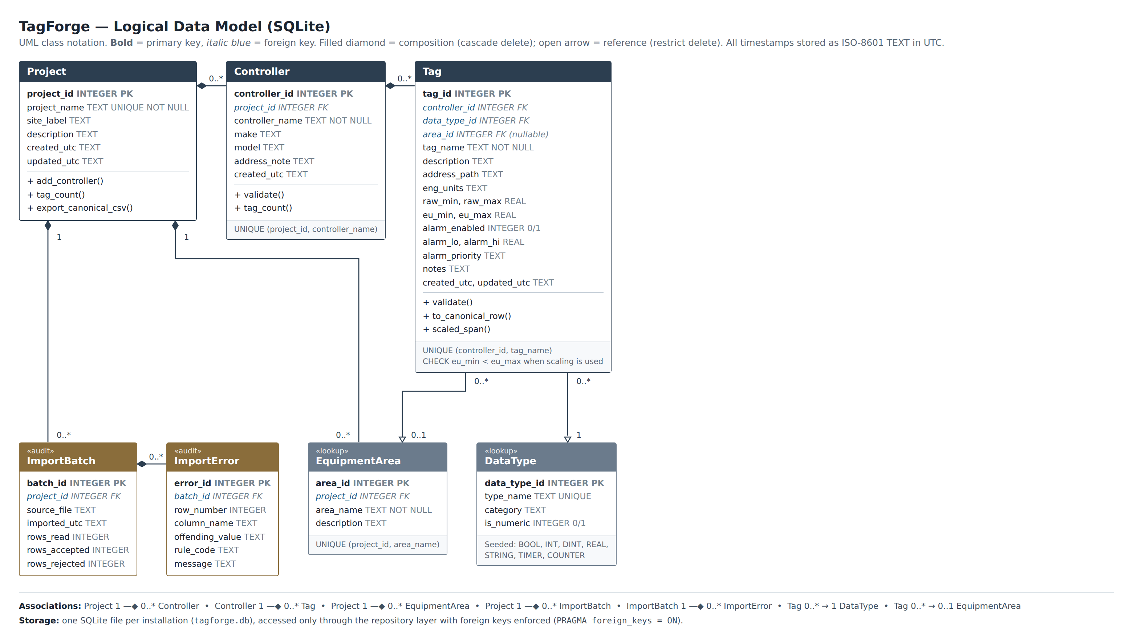
Figure 1. TagForge logical data model (UML class diagram) as implemented in SQLite.

The database has seven tables divided into three groups. Project, Controller, and Tag hold the main records the user creates and edits. DataType and EquipmentArea are lookup tables that keep sortable and filterable fields consistent. DataType is loaded on first run with BOOL, INT, DINT, REAL, STRING, TIMER, and COUNTER. EquipmentArea is created by the user for each project. ImportBatch and ImportError keep a history of each CSV import and explain why any rows were rejected.
Names only need to be unique where it makes sense. A tag name must be unique inside its controller, but the same name can be used on another controller. The database enforces this with UNIQUE (controller_id, tag_name). Controller names and equipment area names must be unique within a project, while project names must be unique across the database. These rules also let an import error identify the exact controller that contains a duplicate.
The deletion rules are intentional. Deleting a project also deletes its controllers, equipment areas, and import batches. Deleting a controller deletes its tags. This keeps orphaned records from being left behind. Lookup records work differently. A data type or equipment area cannot be deleted while a tag is still using it. SQLite foreign-key enforcement is enabled at runtime with PRAGMA foreign_keys = ON because SQLite leaves it off by default.
Indexes are placed on the fields the interface searches and filters most often. The index on (controller_id, tag_name) supports the uniqueness rule and the normal Tag Browser sort. Indexes on area_id and data_type_id support those filters, and an index on tag_name supports searches across controllers. The success criteria only require 50 tags, but a real project can contain several thousand. These indexes should keep searches responsive as the database grows.
All timestamps are stored as ISO-8601 text in UTC. This keeps exported CSV files sortable in a spreadsheet and avoids confusion when the database moves between computers in different time zones. Scaling and alarm values are stored as nullable REAL fields. BOOL and STRING tags do not have an engineering range, so those fields should stay empty instead of being filled with meaningless zeros. Validation only requires them for numeric data types.
Only the repository layer reads from or writes to SQLite. The services and Flask routes work with regular record objects and do not build SQL statements. This keeps transaction handling, parameter binding, and database constraints in one place and makes that code easier to test. Schema creation and lookup seeding are handled by versioned migrations. The database also stores its schema version so the application can detect an older or newer file before opening it in a way that could damage the data.

Screen Mockups
The interface is a NiceGUI application that runs on localhost. It is built around the three main tasks: finding a tag, editing a tag, and importing tags from a CSV file. Each screen calls the Flask API instead of connecting directly to SQLite, so the same validation messages are used by the interface, API, import process, and stored-record audit. The screens use the same basic layout: context and inputs on the left, status tiles across the top, and the main working area below. These figures come from the working interface shell. They show the empty state because the database has not been initialized yet.
Tag Browser | 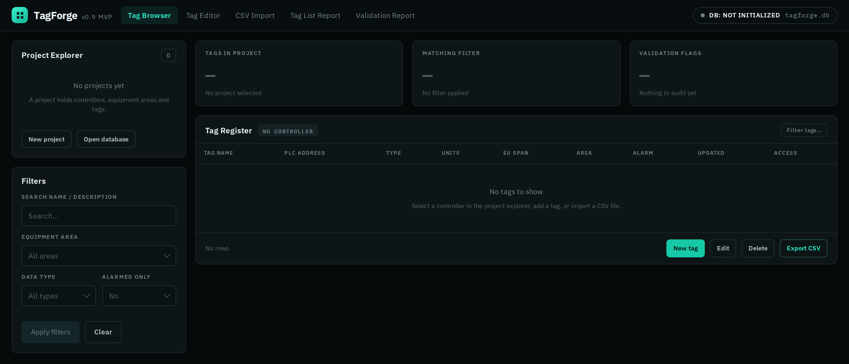  Figure 2. Tag Browser — project explorer, filter panel, status tiles, and the tag register, shown before a database is opened.
The Tag Browser is the application's home screen. The project explorer on the left lists projects and the controllers under them, including the tag count for each controller. The filter panel sits below it. Selecting a controller limits everything on the right to that controller, and an accent line shows the current selection. When no database is open, the explorer explains what a project contains and gives the user the two available ways to create or open one.
The three status tiles show the information a user needs before reading the table: total tags in the project, tags matching the current filters and sort, and stored records that fail validation. The validation tile makes data problems visible without requiring the user to run a separate report. The filter panel includes the four filters required by the success criteria: text search across tag name and description, equipment area, data type, and an alarmed-only option. The filters can be combined, and the matching-tag count makes it clear when the table is only showing part of the controller's tag list.
The register table contains the fields a user normally scans. Its headers remain visible when the table is empty so the user can still see the structure of a tag record. Alarm status appears as a badge instead of two extra numeric columns. Records that fail the audit also show the rule code in the list, so the problem is visible before the record is opened. Row actions are placed in the table footer beside the paging controls instead of being repeated on every row. Export CSV writes the currently filtered rows in the standard column order, so the exported file matches what is on the screen.

Tag Editor | 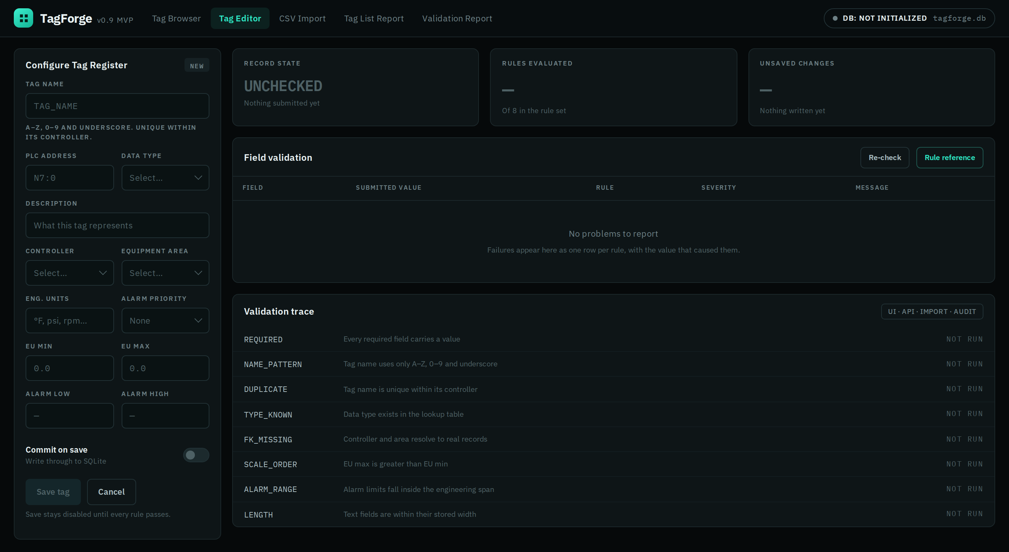  Figure 3. Tag Editor — the record form with the field validation table and the eight-rule validation trace beside it.
The Tag Editor shows the tag record and its validation information side by side. The form is on the left and places related fields together: identity first, then scaling, then alarming. Each field shows the type of value it expects. The tag-name field also shows its naming rule before the user enters anything instead of waiting until the save fails.
The three tiles show whether the record has been checked, how many of the eight rules have run, and how many fields contain unsaved changes. Save stays disabled until every rule passes. In this empty-state figure, it is disabled because no valid record has been entered. Nothing is written to the database until the record passes validation and the user saves it.
Validation failures appear in the Field Validation table, one row for each failed rule. The row shows the field, submitted value, rule code, severity, and a message explaining the problem. The import report uses the same format, so the user does not have to learn two different error displays. The validation trace below the table lists all eight rules, what each one checks, and its current result. It shows NOT RUN here because no record has been submitted. After a save attempt, each rule shows PASS or FAIL. The UI, API, import, and audit all use the same validation module and rule-code messages. This is one of the three reusable components required by the project.

CSV Import and Validation Review | 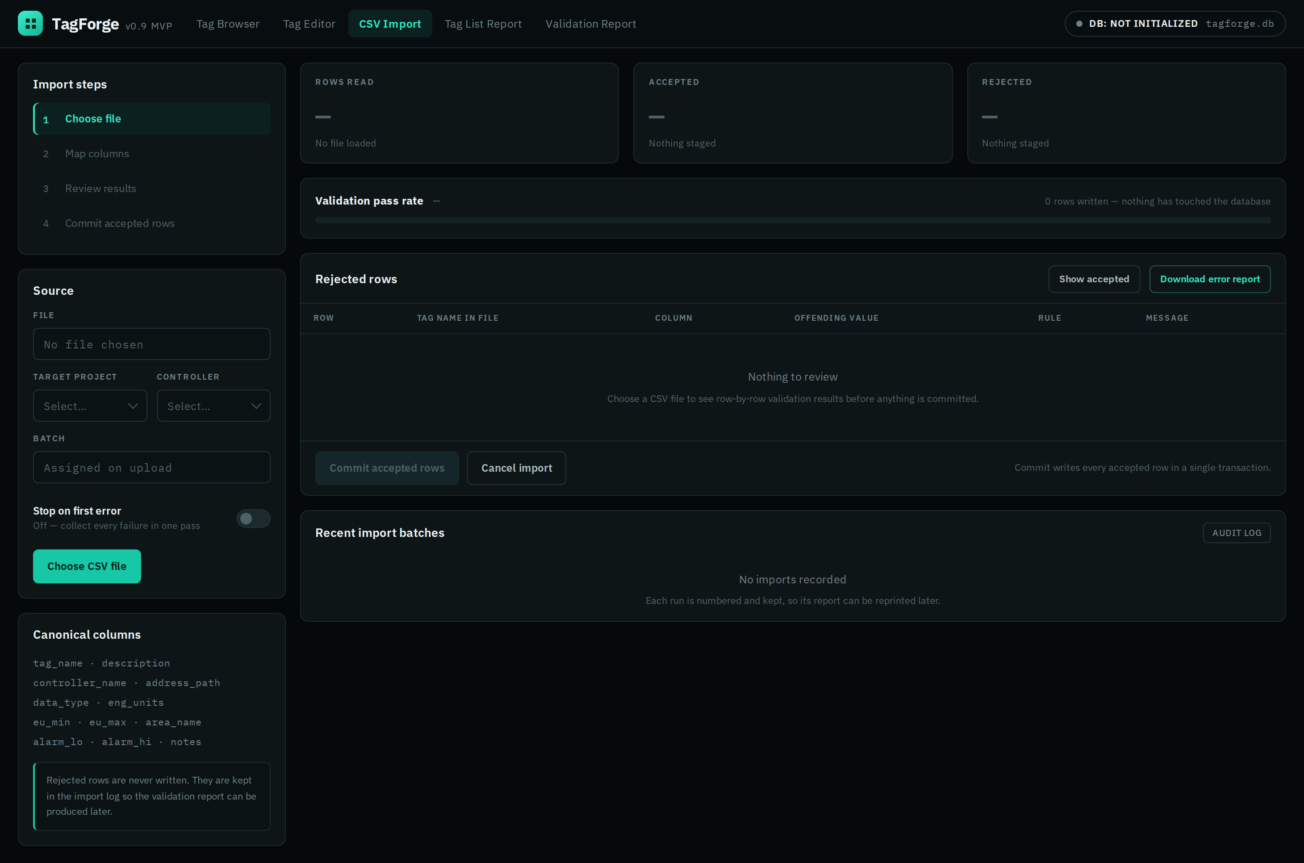  Figure 4. CSV Import — the wizard at step one, with the review and commit surfaces that fill once a file is chosen.
CSV import uses four steps: choose a file, map its columns to the standard fields, review the validation results, and commit the import. The left side shows the current step, selected file, target project and controller, column mapping, and the error-handling option. By default, the import checks the entire file and reports every problem instead of stopping at the first error. This gives the user one complete list to correct in the spreadsheet.
Nothing is added to the database before the user commits. The screen makes that clear in three places. The tiles show rows read, accepted, and rejected. The pass-rate row shows how many rows have been written. The commit button states exactly how many rows it will add. All of those values are empty in the figure because no file has been selected.
Each rejected row includes the file row number, bad column, bad value, rule code, and a message written for someone correcting the source file. The import must handle the problems that normally appear in a real export: an invalid tag name, unknown data type, duplicate tag, missing required value, reversed scaling limits, an alarm outside the engineering range, and a controller that does not exist in the selected project.
When the user commits, the accepted rows are written in one transaction. The complete group is written or nothing is written. TagForge keeps the batch and its errors afterward. This fills the recent-batches panel, allows the Import Validation Report to be produced later, and lets the user correct the file and import the remaining rows as a second numbered batch.

Report Mockups
TagForge produces two reports. Each report can be viewed inside the application and exported to PDF or CSV from its toolbar. The on-screen report follows the application theme, while PDF and print output use a light layout that reads like a normal document. Both reports use the same repository queries as the interface. Their headers show the project, filter or batch, report number, revision, and generation time so a printed or emailed copy can still be traced to its source. The figures show the empty report layouts before any data has been added.
Controller Tag List (TF-R01) | 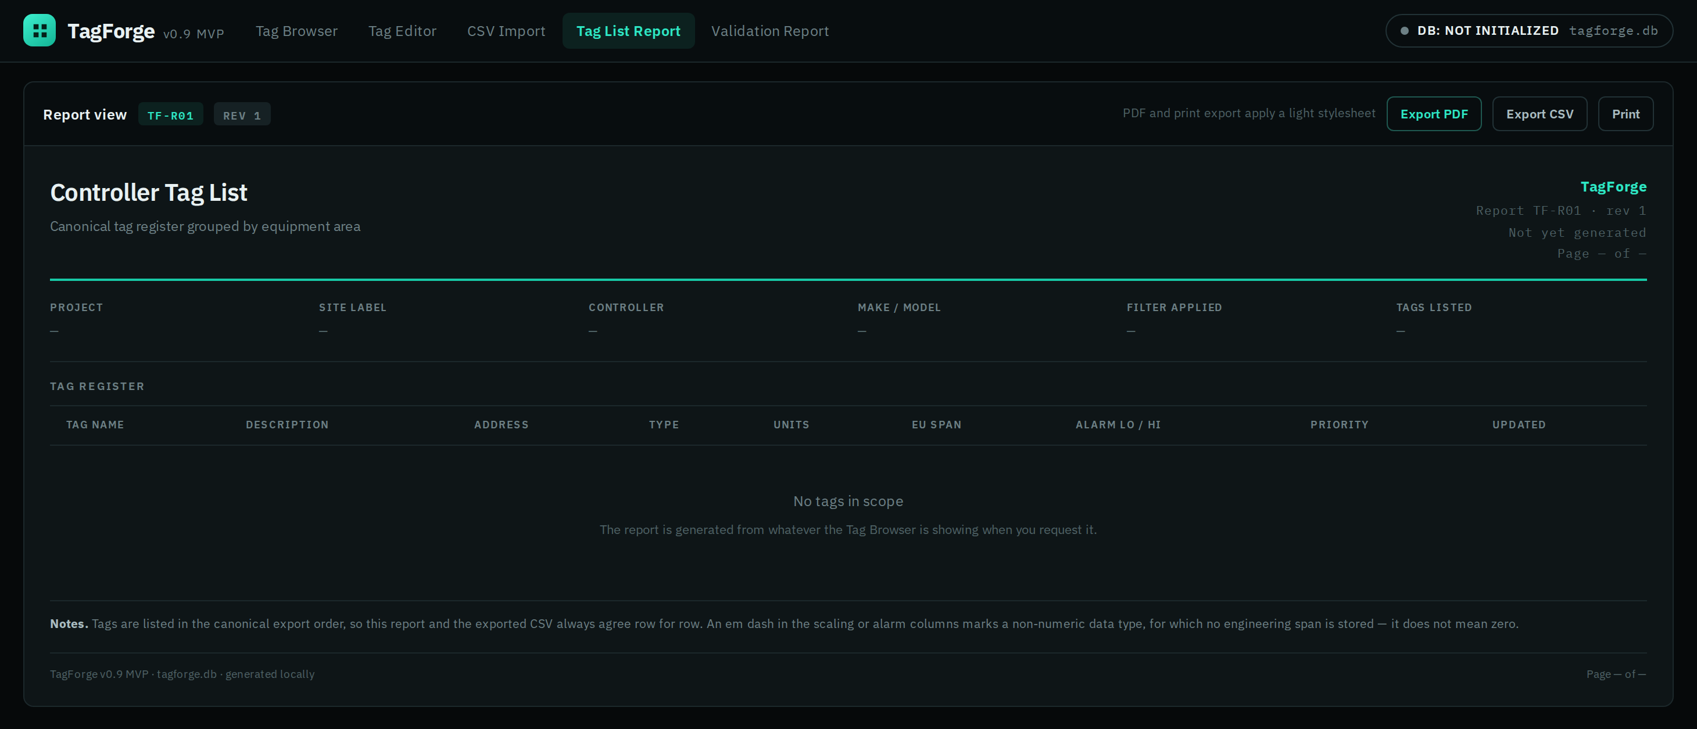  Figure 5. Controller Tag List (TF-R01) — report view with the header block and register columns in place.
The Controller Tag List is used to review a controller outside the main register screen. Tags are grouped by equipment area and listed in the same standard order as the CSV export. This keeps the report and exported spreadsheet matched row for row.
The header shows the project, site label, controller, make and model, active filter, and number of listed tags. Showing the filter is important because the reviewer needs to know whether the report contains the whole controller or only one equipment area. The table includes the fields normally checked against field devices: address, data type, engineering units, engineering range, alarm limits, and priority. Non-numeric tags display a dash in scaling and alarm columns instead of zero. This makes it clear that the field does not apply rather than making it look like the value was set to zero.
The report uses the same filtered rows visible in the Tag Browser when the user requests it. This makes the exported report reproducible from the screen instead of relying on a separate query with different results.

Import Validation Report (TF-R02) | 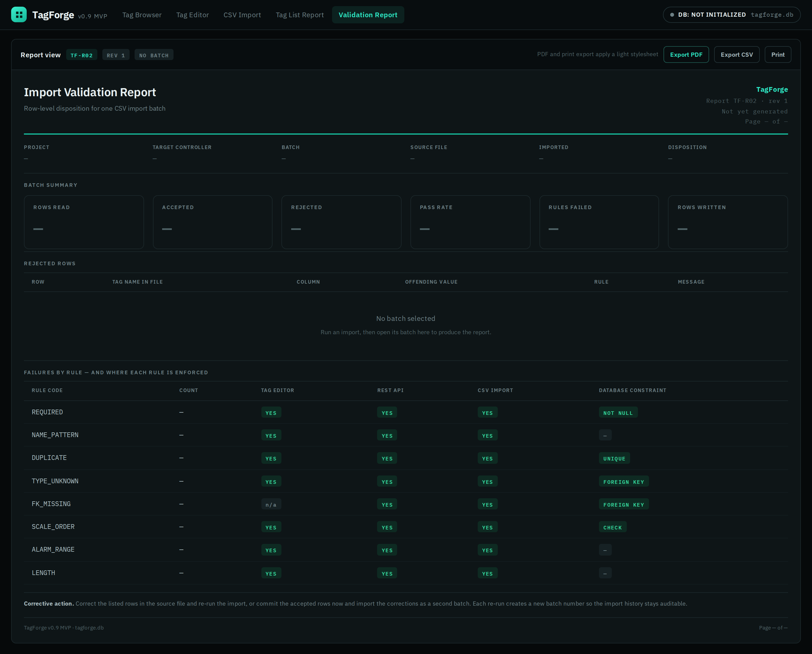  Figure 6. Import Validation Report (TF-R02) — batch summary and rejected rows empty; the rule enforcement map populated.
The Import Validation Report is the row-level error report required by the project scope. It documents one import batch, including the source file, run time, rows read, rows accepted, rows rejected, and whether the batch was committed. The disposition appears in both the header and toolbar because rejected rows mean something different depending on whether the accepted rows were already written.
The batch summary tiles and rejected-row table are filled from the selected import batch. They are empty in this figure because no import has been run. Each rejection shows the file row, tag name from the source file, column, bad value, rule code, and the correction that is needed.
The second table lists every validation rule and shows where it is enforced: the Tag Editor, REST API, CSV import, and database constraint where one is available. Unlike the batch results, this information comes from the rule set, so it can be displayed before any file is imported. It shows that the same rules apply no matter how data is entered. It also identifies rules that depend completely on application code because there is no matching database constraint. Since the report uses saved ImportBatch and ImportError records, it can be generated again later. The final note gives the user two choices: fix the source file and run it again, or commit the accepted rows and import the corrected rows in a second batch.

Maintenance Features
This release is a single-user local application, so it does not need passwords or user administration. Its maintenance tools focus on keeping the local database reliable throughout a project. They cover the database file, lookup lists, import history, sample data, and application diagnostics. All of the tools are available from one Maintenance page and are included in the acceptance tests.
Database initialization and schema version. On the first run, TagForge creates tagforge.db, builds the schema, loads the DataType values, and saves the schema version. On later starts, it compares the database version with the version expected by the application. A newer database is refused with a clear message. An older database can be migrated forward after an automatic backup, and the migration runs inside a transaction.
Backup and restore. Backup creates a timestamped copy of the database in a folder chosen by the user and reports the file size and saved record counts. Restore checks the backup's schema version before replacing the current database and asks the user to confirm. Since the whole database is one file, backup and restore can stay simple while still protecting the user's work.
Stored-record audit. This tool runs the complete validation rule set against records already in the database and reports anything that would fail now. A saved record can become invalid even when it was not edited. For example, an equipment area could be renamed, a data type could be retired, or the record could have been created by an older version with weaker rules. The audit uses the same rule codes as the editor and import. Its results can be exported so the user can work through a list instead of finding problems by accident.
Lookup list maintenance. Users can create, rename, and delete equipment areas and add data types that are not included in the original list. A lookup value cannot be deleted while tags still reference it. The error message shows how many tags use the value and offers to display them. Renaming is allowed because tags reference the record by its key and automatically follow the new name.
Import history and purge. The Maintenance page lists previous imports with the file name, timestamp, accepted rows, and rejected rows. The user can reprint the validation report for any saved batch. Import audit records grow over time but do not affect tag data, so the purge tool can remove batches older than a selected date after showing and confirming the number that will be deleted.
Sample data and reset. The sample-data loader installs the fictional project used for testing and the final walkthrough. Reset returns the database to a new, empty state. Both actions require typed confirmation. Together, they make it easy to demonstrate the application from a clean computer without using real customer information.
Diagnostics. The status panel shows the database path and size, schema version, record counts by table, application version, Python version, and log-file location. Startup, migrations, backups, imports, and unhandled errors are written to a rotating local log. That log is the first place to check when a user reports a problem that cannot be reproduced.

Work Breakdown Structure (WBS)
The work breakdown structure below assigns the 100 budgeted hours from the proposal to seven work packages and places them on the fourteen-week term schedule. Bars show each package's planned working window, and diamonds mark milestones that have defined acceptance criteria rather than being calendar markers. Hours, not weeks, are the unit of control: packages overlap by design, and a week's calendar space does not imply a week's worth of effort.
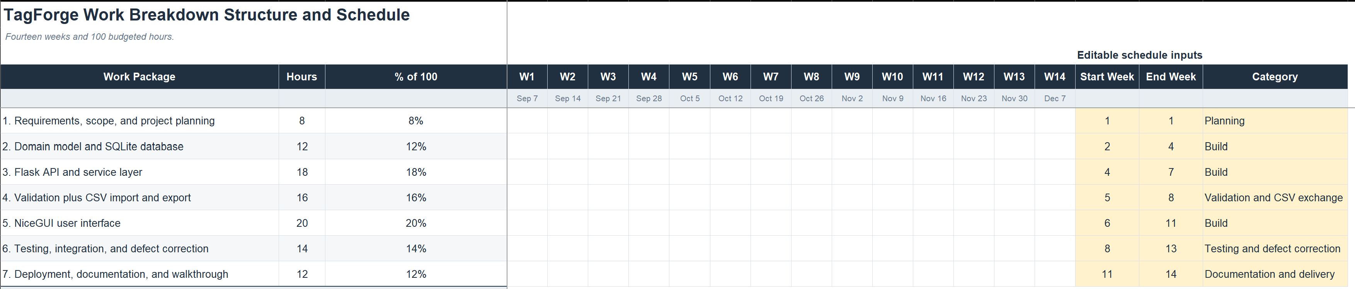
Figure 7. Work breakdown structure and fourteen-week schedule against the 100-hour budget.
The critical path runs through packages 2, 3, and 5: the schema has to be stable before the API is worth writing, and the API has to return real records before the interface can be built against it. Package 4, validation and CSV exchange, is scheduled to overlap packages 3 and 5 on purpose. The validation module is shared by all three entry paths, so it is written once, early, and then consumed rather than reimplemented. This is the mitigation for the integration risk named in the proposal, and M2 is where it is proven.
The milestones are acceptance gates. M1 approves this design document. M2 is the early vertical slice the proposal committed to: create one valid tag, save it, restart the application, retrieve it, and search for it. M3 freezes the schema and the API surface, after which changes to either require a deliberate decision rather than a convenience edit. M4 proves the CSV round trip, exporting a tag list and importing it back with no loss and no spurious rejections. M5 declares the MVP feature-complete and stops new features. M6 is the code freeze once the acceptance tests pass, and M7 is submission and walkthrough.
The final twenty hours, the tails of packages 6 and 7, are reserved for integration, defect correction, setup instructions, documentation, and walkthrough preparation, exactly as the proposal budgeted. That reserve is the schedule's buffer, and it is protected: if an earlier package runs long, the response is to move a feature into the backlog, not to spend the reserve. Hours are logged weekly against the budget, and the weekly review compares hours consumed to acceptance criteria met rather than to a percentage estimate of completion.
Scope expansion is the largest risk in the project, and the schedule is the instrument that controls it. Multiple vendor formats, live controller connections, revision history, and user accounts are all recorded in the backlog and none of them appear on this chart. After M5, any new feature request is logged for a post-course release rather than scheduled, and after M6 only defect corrections are made.

Summary
TagForge uses three layers with a clear rule for how they communicate. The NiceGUI interface calls the Flask API. The API calls services that apply the business rules. Only the repository layer can access SQLite. This gives the validation module, database repository, and shared record and CSV mapping functions one clear location and one set of tests instead of spreading the same logic throughout the application.
The SQLite database contains seven tables. Project, Controller, and Tag hold the main records. DataType and EquipmentArea keep filterable values consistent. ImportBatch and ImportError keep CSV imports traceable after they finish. Scoped uniqueness, cascade rules, foreign keys, and CHECK constraints make the database the final protection against invalid or orphaned data.
The interface covers the workflow the project is graded on. The Tag Browser finds records. The Tag Editor corrects them and explains failed rules. The CSV wizard validates an entire batch before anything is written. The Controller Tag List and Import Validation Report make the same information available on screen and as PDF or CSV files. Backup and restore, schema versioning, the stored-record audit, lookup maintenance, import history, and diagnostics help keep the local database dependable throughout the project.
The schedule divides the 100 available hours into seven work packages over fourteen weeks. It includes seven acceptance milestones and keeps twenty hours at the end for integration, documentation, and the final walkthrough. The MVP stays focused on one standard schema and one CSV format. Vendor importers, revision history, user accounts, and live-system connections remain in the backlog. The goal is to finish a small application that does one useful job completely instead of building a larger application that only does several jobs halfway.

